PROJECT TESTING PHASE
Project Title
Streamlining IT Procurement: Automating Standard Laptop Orders with Flow Designer

1. Service Catalog Testing
- Click All.
- Search for Service Catalog.
- Click Service Catalog.
- Click Hardware.
- Find Standard Laptop.
- Select Standard Laptop.
- Click Order Now to place the request.
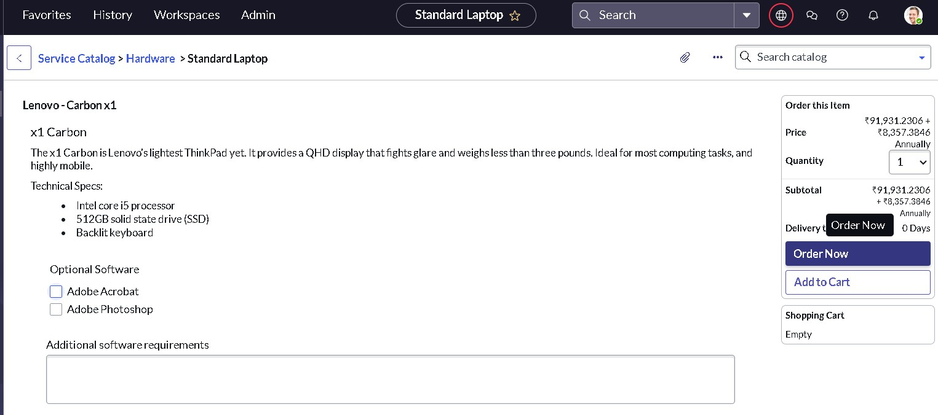

2. Order Status Verification
- Check the Order Status.
- Click on the Request Number.
- The Requested Number record will open.
- Scroll down to the Approvers section.
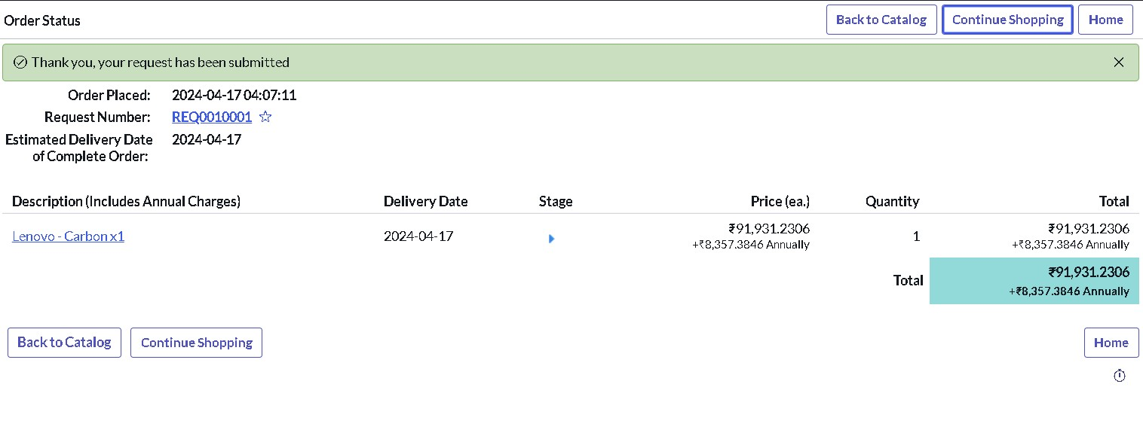
3. Approval Verification
- Right-click on the record.
- Click Approve.
- Click on the Requested Item section.
- Open the Requested Item record.
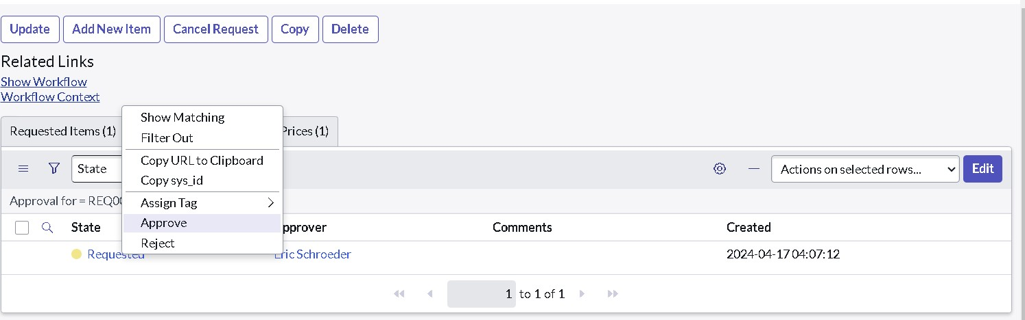

4. Catalog Task Verification
- Scroll down to the Catalog Tasks section.
- Open the Catalog Task record.
- Check the updated Status.
- Check the Short Description.
- Check the Assigned Group.
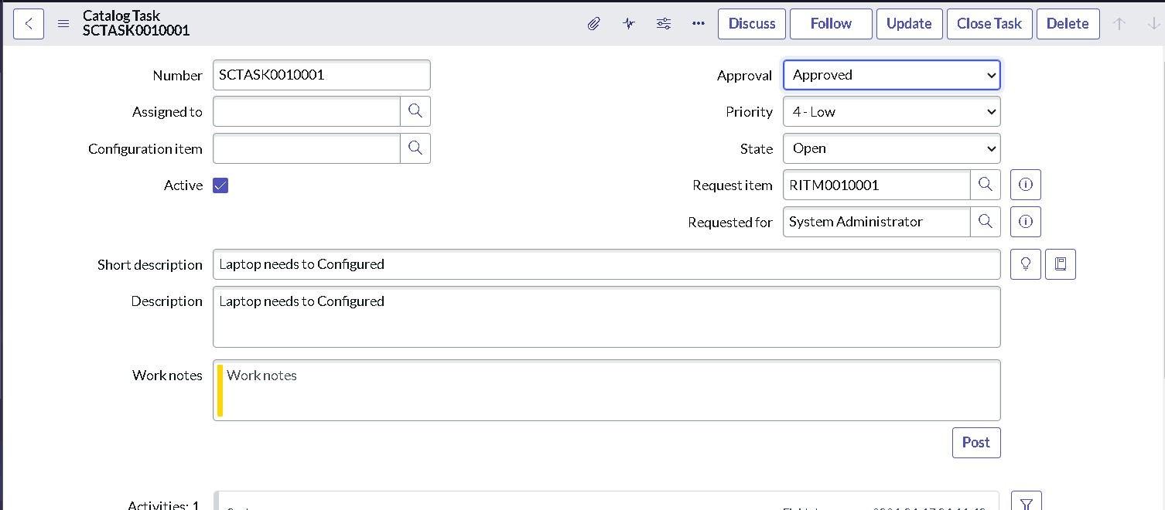

5. Expected Testing Result
The Standard Laptop request should proceed through the Service Catalog, approval and Requested Item process. The Catalog Task should be available with the updated status, “Laptop need to Configured” short description and Hardware as the assigned group.

